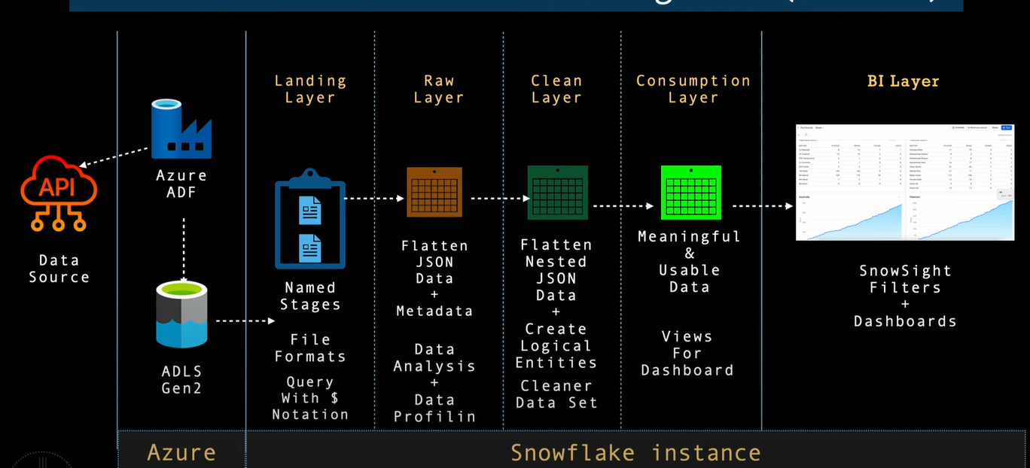

**Snowflake** is a cloud-based platform where you can **store data, clean it, and run SQL queries** — all in one place. It’s great for working with big files like JSON and organizing them into clean tables.

In my cricket project, I used Snowflake to:

* **Load JSON files**
* **Explore and clean the data**
* **Convert it into useful tables** for analysis and visualization

It helped me build a full ETL pipeline without needing extra tools.

### **Project Overview – Cricket ETL in Snowflake**

* **Landing Layer:** I assumed the data was fetched from AWS (as shown in the diagram), but for this project, I directly imported 28 local JSON files into Snowflake using a named stage and defined a JSON file format.
* **Raw Layer:** I copied the JSON data into a raw table without flattening it, and focused on understanding the structure, metadata, and exploring the nested fields.
* **Clean Layer:** I flattened the nested JSON data (players, deliveries, etc.), created clean structured tables, and applied transformations to make the data usable.
* **Consumption Layer:** I created fact and dimension tables from the cleaned data and established relationships between them to support meaningful analysis.

-- Create all 4 schemas inside the cricket database

CREATE OR REPLACE SCHEMA cricket.land;

CREATE OR REPLACE SCHEMA cricket.raw;

CREATE OR REPLACE SCHEMA cricket.clean;

CREATE OR REPLACE SCHEMA cricket.consumption;

show schemas in database cricket;

-- Set context to land

USE SCHEMA cricket.land;

-- Define JSON file format

CREATE OR REPLACE FILE FORMAT cricket.land.my_json_format

TYPE = 'JSON'

NULL_IF = ('\\n', 'null', '')

STRIP_OUTER_ARRAY = TRUE

COMMENT = 'JSON File Format with outer strip array flag set to true';

-- Create internal stage

CREATE OR REPLACE STAGE cricket.land.my_stg;CRICKET.LAND.MY_STGCRICKET.LAND.MY_STG

list @my_stg/cricket/json/;

-- quick check if data is coming correctly or not

select

t.$1:meta::variant as meta,

t.$1:info::variant as info,

t.$1:innings::array as innings,

metadata$filename as file_name,

metadata$file_row_number int,

metadata$file_content_key text,

metadata$file_last_modified stg_modified_ts

from @my_stg/cricket/json/1384401.json (file_format => 'my_json_format') t;

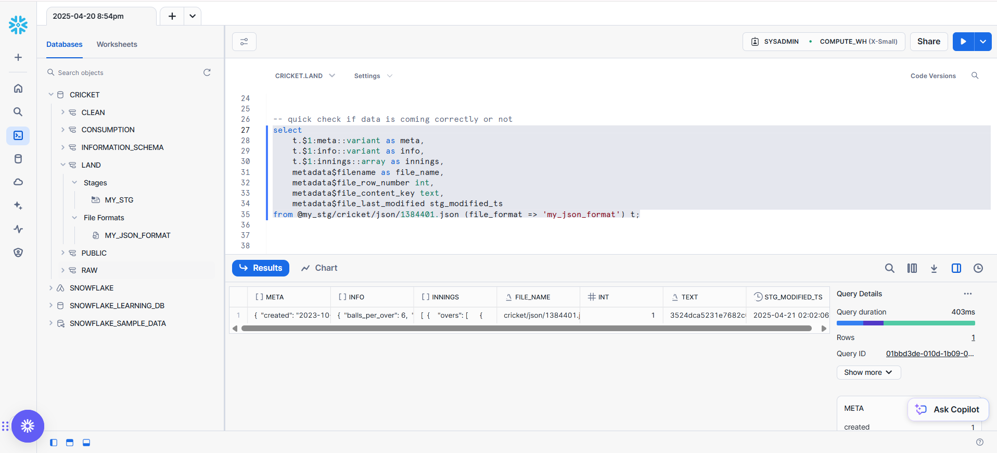  
  
Here we have loaded all the data in stg location.  
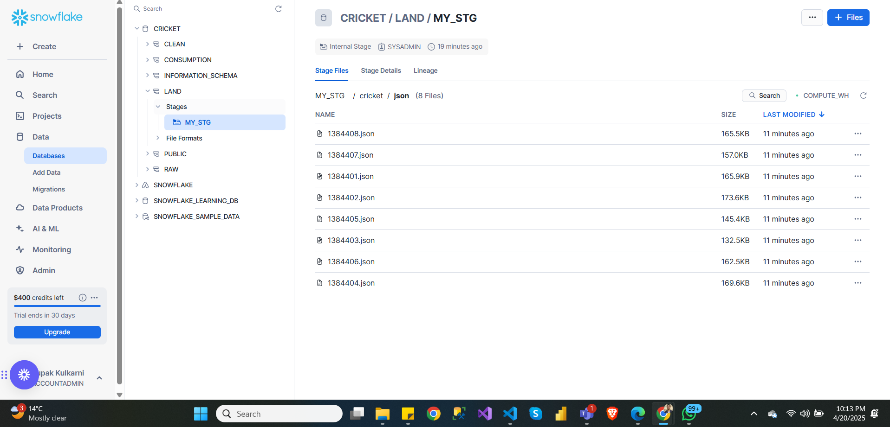  
  
Now I will use copy command to load data from landing (staging layer) to raw layer.|  
  
-- lets create a table inside the raw layer

create or replace transient table cricket.raw.match_raw_tbl (

meta object not null,

info variant not null,

innings array not null,

stg_file_name text not null,

stg_file_row_number int not null,

stg_file_hashkey text not null,

stg_modified_ts timestamp not null

)

comment = 'This is raw table to store all the json data file with root elements extracted';

copy into cricket.raw.match_raw_tbl from

(

select

t.$1:meta::object as meta,

t.$1:info::variant as info,

t.$1:innings::array as innings,

metadata$filename,

metadata$file_row_number,

metadata$file_content_key,

metadata$file_last_modified

from @cricket.land.my_stg/cricket/json

(file_format => 'cricket.land.my_json_format') t

)

on_error = continue;

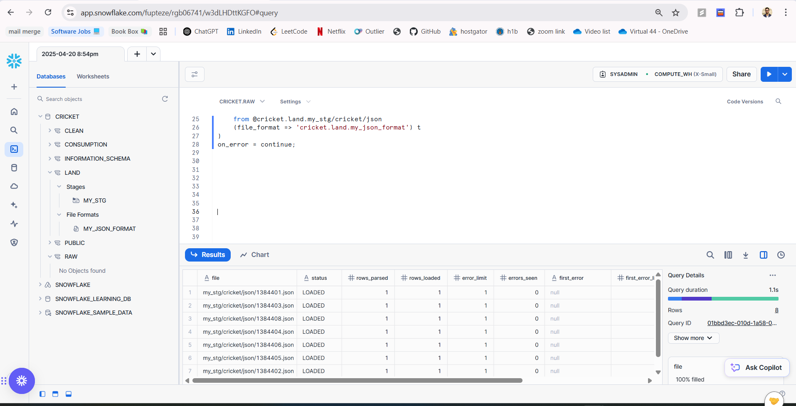

Now we are under clean zone.  
  
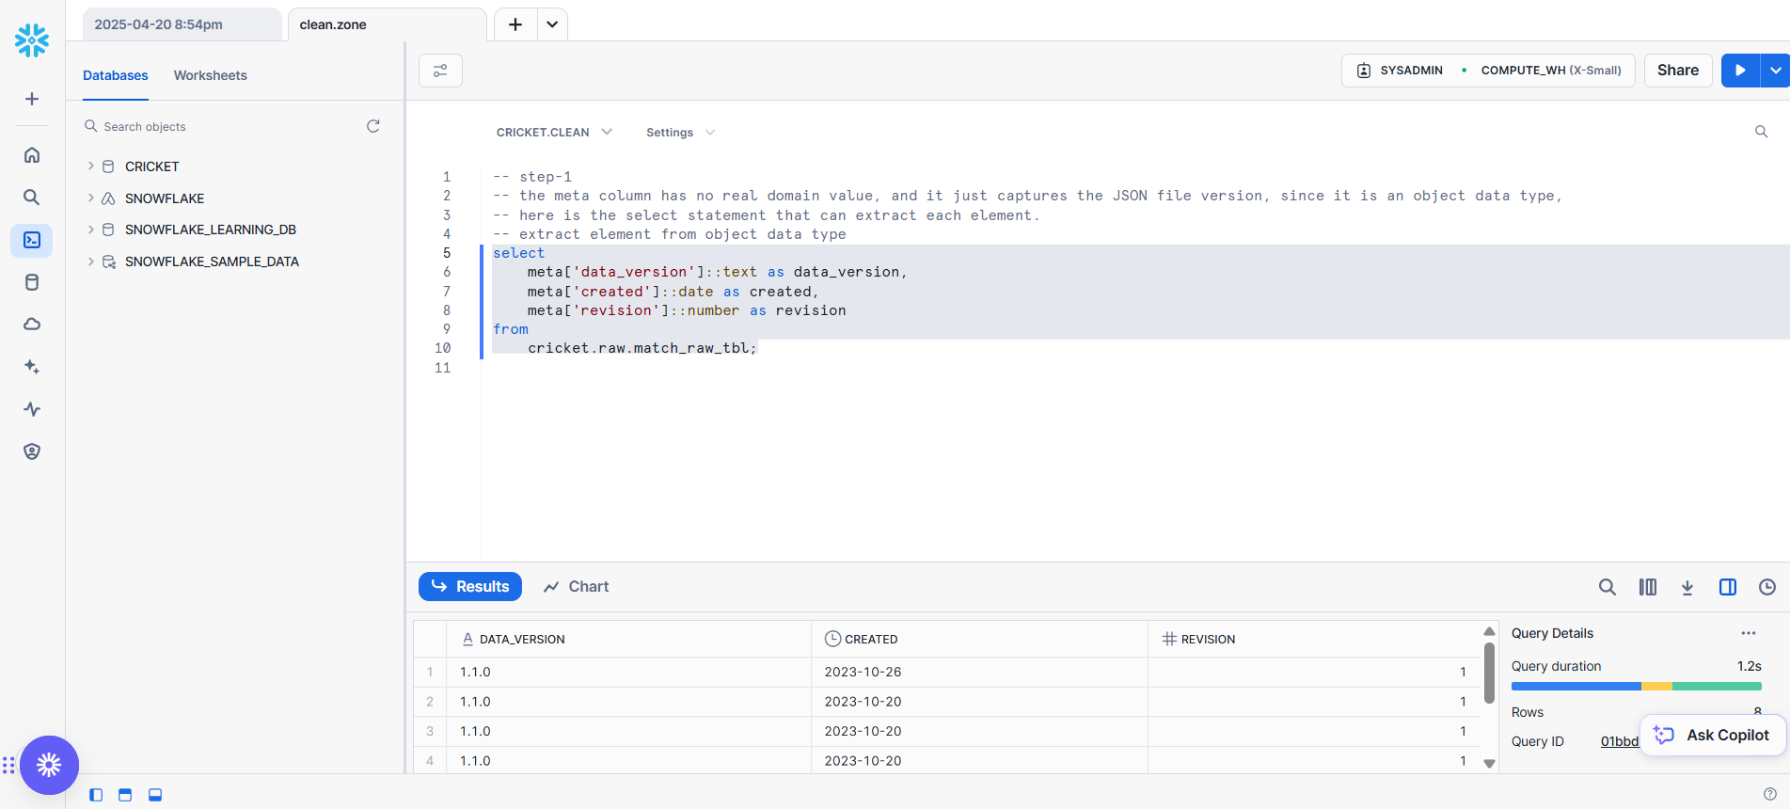

-- step-1

-- the meta column has no real domain value, and it just captures the JSON file version, since it is an object data type,

-- here is the select statement that can extract each element.

-- extract element from object data type

select

meta['data_version']::text as data_version,

meta['created']::date as created,

meta['revision']::number as revision

from

cricket.raw.match_raw_tbl;

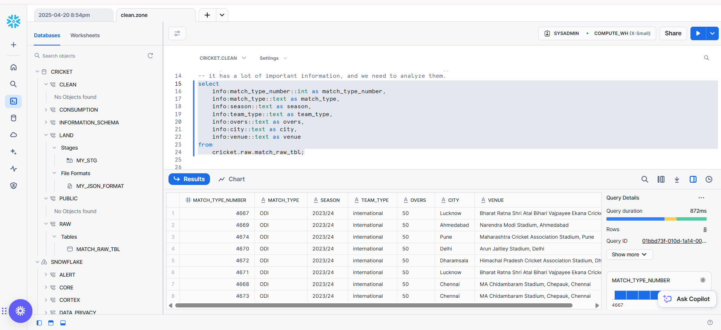

-- step-2 extract elements from info column that is of variant data type

-- it has a lot of important information, and we need to analyze them.

select

info:match_type_number::int as match_type_number,

info:match_type::text as match_type,

info:season::text as season,

info:team_type::text as team_type,

info:overs::text as overs,

info:city::text as city,

info:venue::text as venue

from

cricket.raw.match_raw_tbl;

When you run code, you can check result of the queries with some analysis of output as well.  
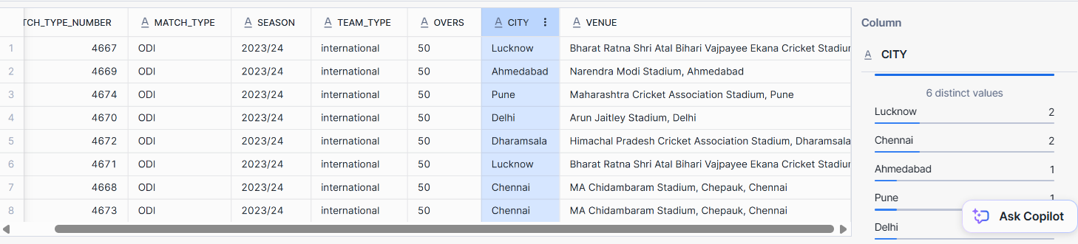

Now lets clean the match table by this query.

create or replace transient table cricket.clean.match_detail_clean as

select

info:match_type_number::int as match_type_number,

info:event.name::text as event_name,

case

when

info:event.match_number::text is not null then info:event.match_number::text

when

info:event.stage::text is not null then info:event.stage::text

else

'NA'

end as match_stage,

info:dates[0]::date as event_date,

date_part('year',info:dates[0]::date) as event_year,

date_part('month',info:dates[0]::date) as event_month,

date_part('day',info:dates[0]::date) as event_day,

info:match_type::text as match_type,

info:season::text as season,

info:team_type::text as team_type,

info:overs::text as overs,

info:city::text as city,

info:venue::text as venue,

info:gender::text as gender,

info:teams[0]::text as first_team,

info:teams[1]::text as second_team,

case

when info:outcome.winner is not null then 'Result Declared'

when info:outcome.result = 'tie' then 'Tie'

when info:outcome.result = 'no result' then 'No Result'

else info:outcome.result

end as matach_result,

case

when info:outcome.winner is not null then info:outcome.winner

else 'NA'

end as winner,

info:toss.winner::text as toss_winner,

initcap(info:toss.decision::text) as toss_decision,

--

stg_file_name ,

stg_file_row_number,

stg_file_hashkey,

stg_modified_ts

from

cricket.raw.match_raw_tbl;

Query profile  
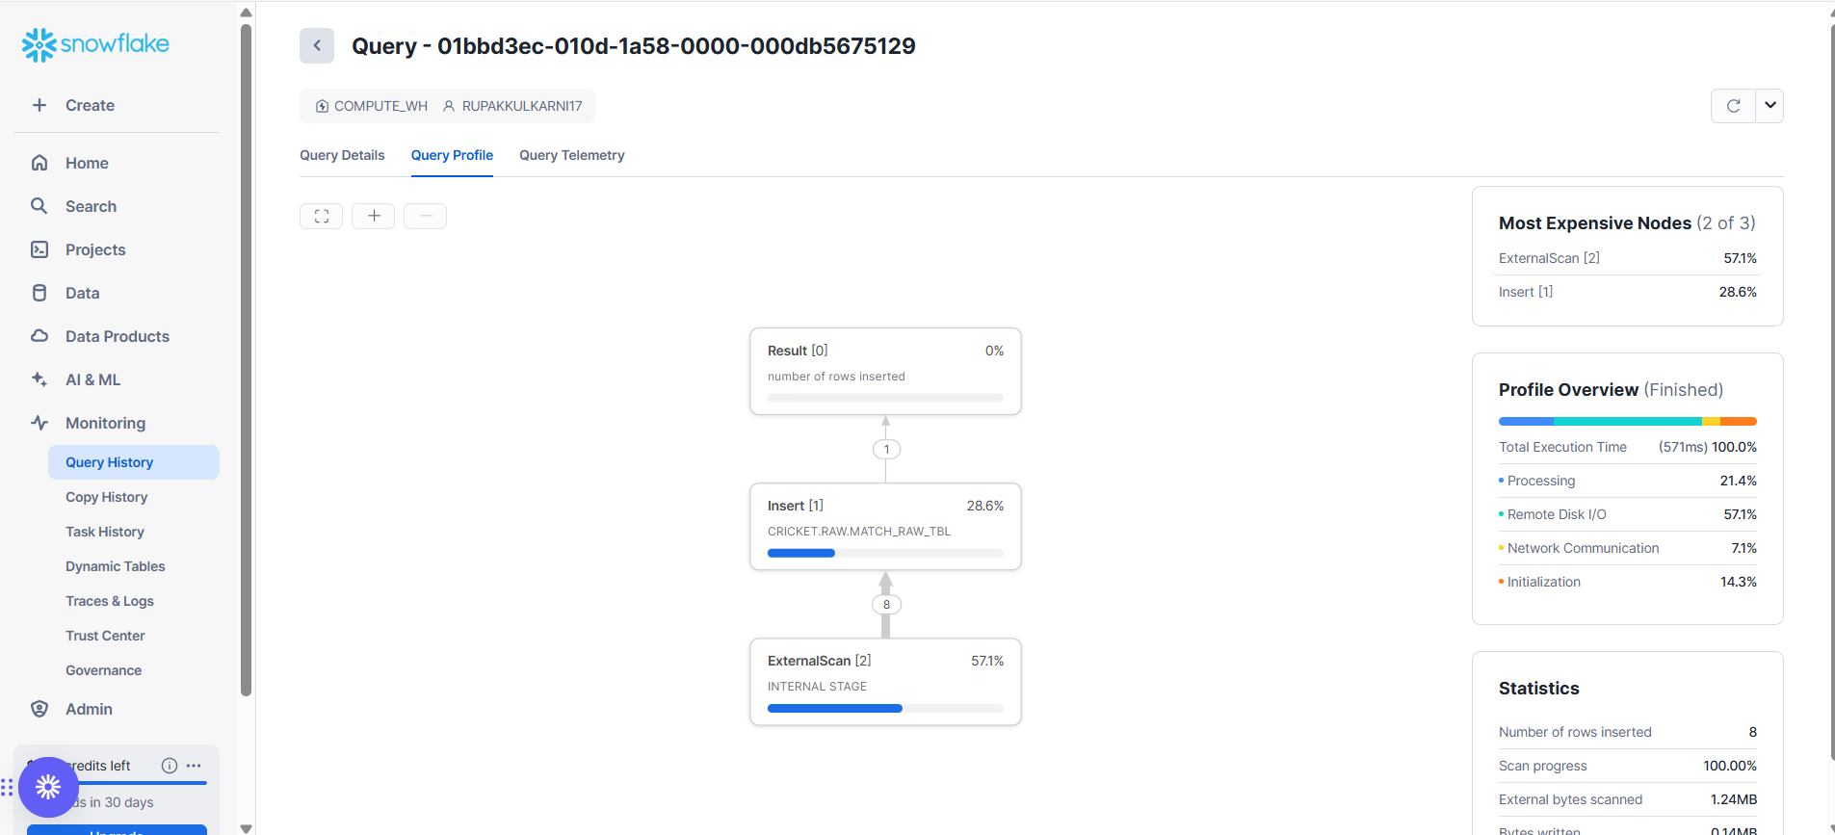

All records, succeeded in raw data.

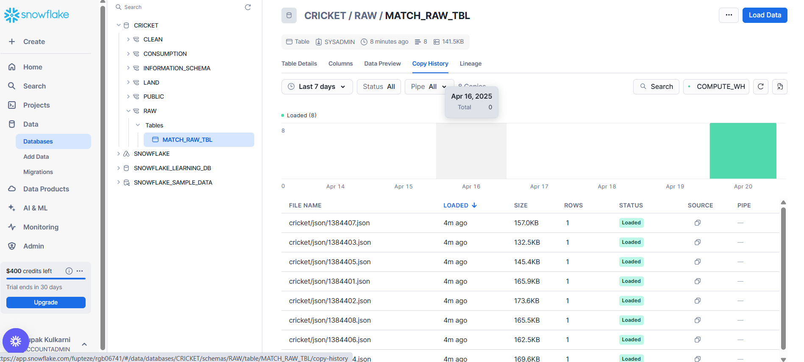

Different column types  
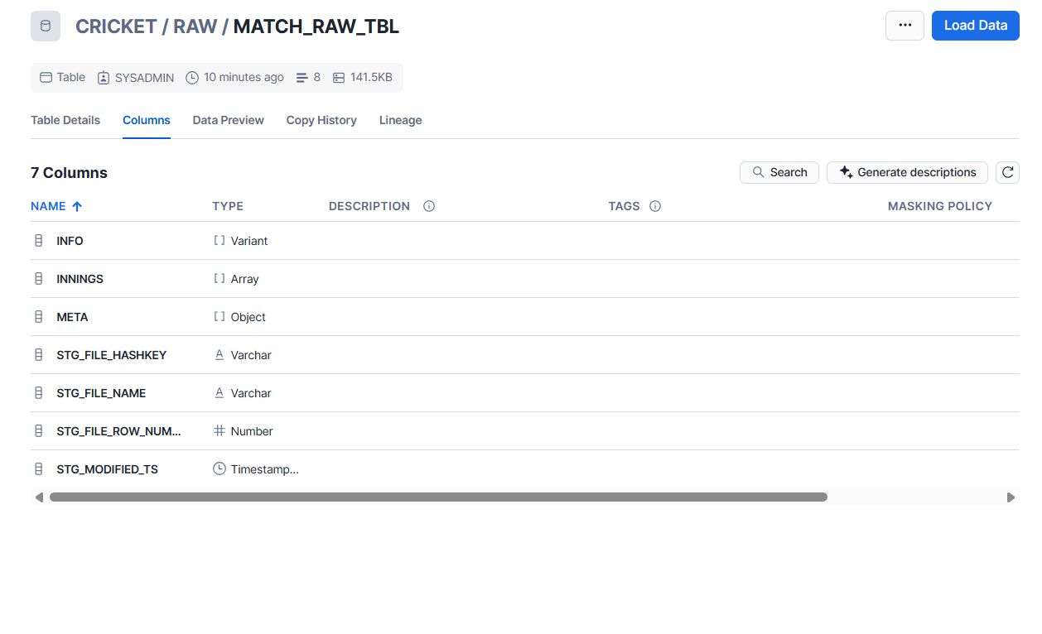

create or replace transient table cricket.clean.match_detail_clean as

select

info:match_type_number::int as match_type_number,

info:event.name::text as event_name,

case

when

info:event.match_number::text is not null then info:event.match_number::text

when

info:event.stage::text is not null then info:event.stage::text

else

'NA'

end as match_stage,

info:dates[0]::date as event_date,

date_part('year',info:dates[0]::date) as event_year,

date_part('month',info:dates[0]::date) as event_month,

date_part('day',info:dates[0]::date) as event_day,

info:match_type::text as match_type,

info:season::text as season,

info:team_type::text as team_type,

info:overs::text as overs,

info:city::text as city,

info:venue::text as venue,

info:gender::text as gender,

info:teams[0]::text as first_team,

info:teams[1]::text as second_team,

case

when info:outcome.winner is not null then 'Result Declared'

when info:outcome.result = 'tie' then 'Tie'

when info:outcome.result = 'no result' then 'No Result'

else info:outcome.result

end as matach_result,

case

when info:outcome.winner is not null then info:outcome.winner

else 'NA'

end as winner,

info:toss.winner::text as toss_winner,

initcap(info:toss.decision::text) as toss_decision,

--

stg_file_name ,

stg_file_row_number,

stg_file_hashkey,

stg_modified_ts

from

Cricket.raw.match_raw_tbl;  
  
  
This code not only creates, but also cleans data through case statements.

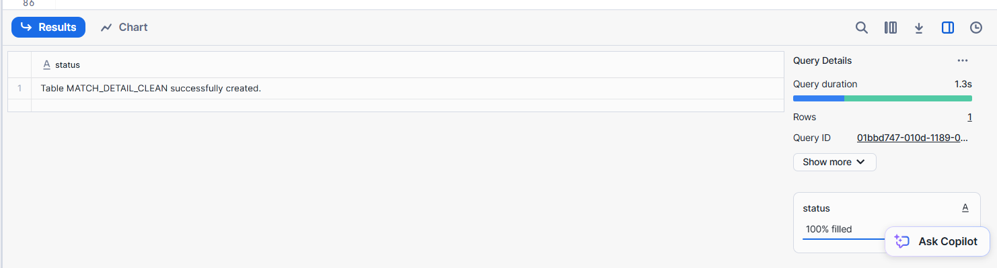

You can also view the statistics of the query output.

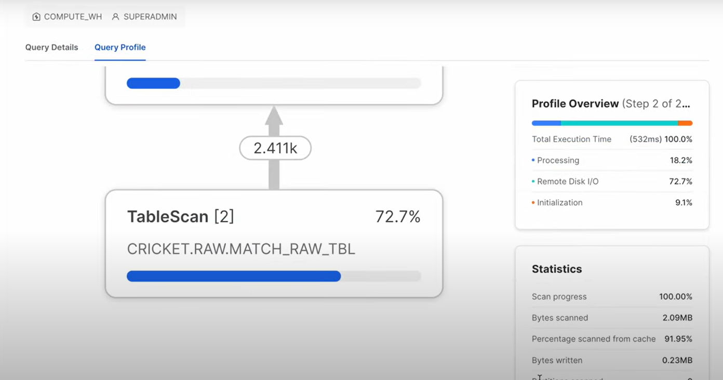

Preview created table match_detail_clean

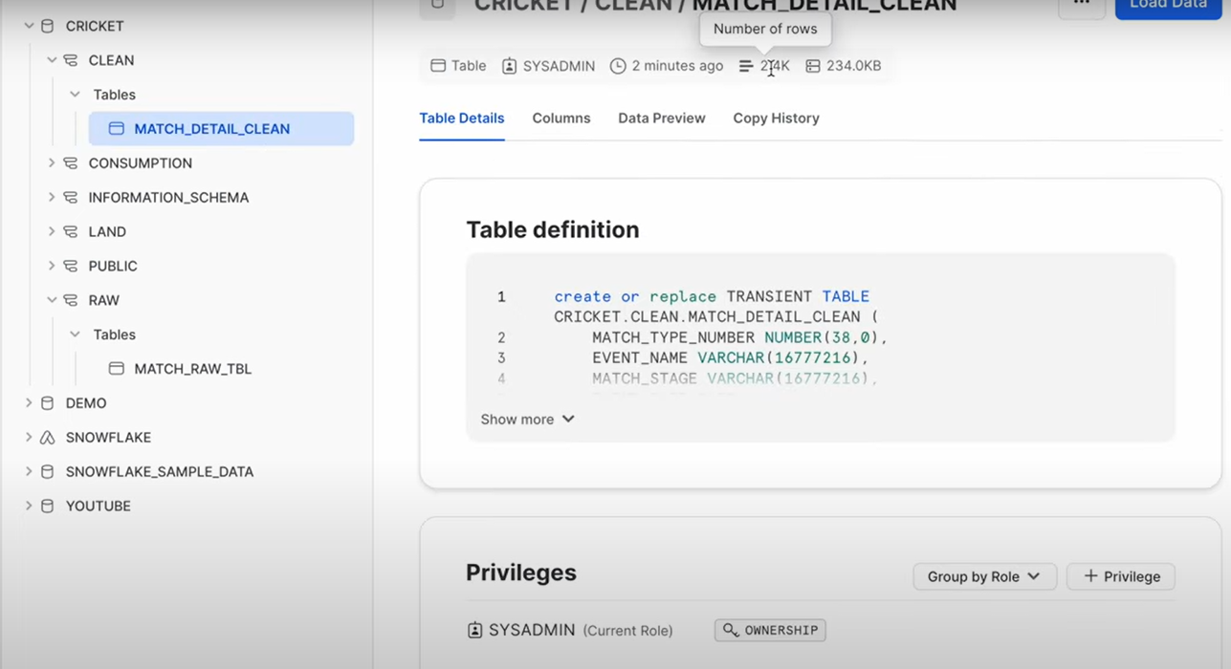

You can view the copy history as well.

Database columns.  
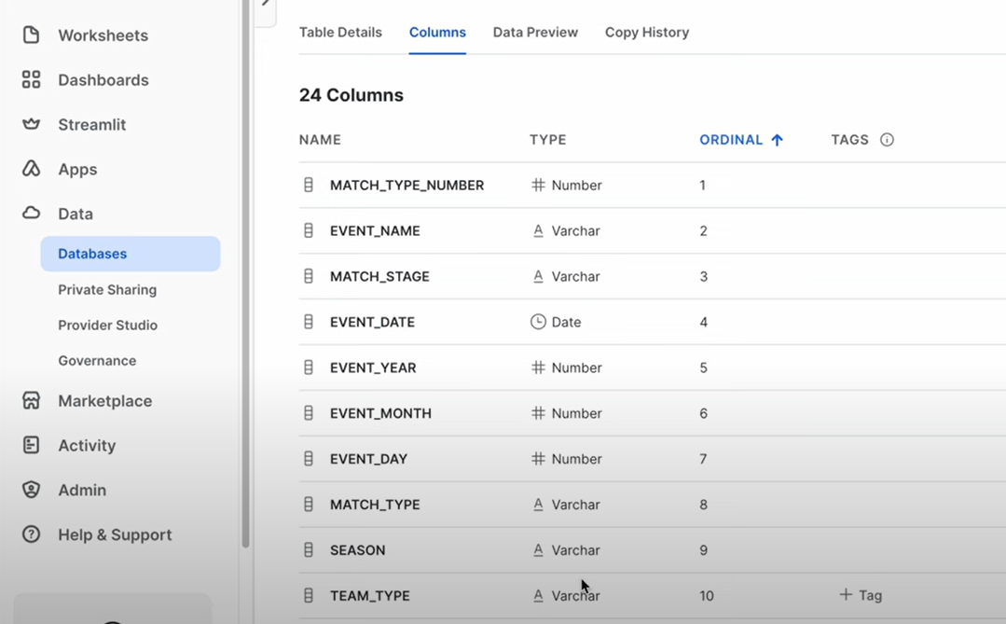

Now lets use flatten function for cleaning more data.

What is flattening.

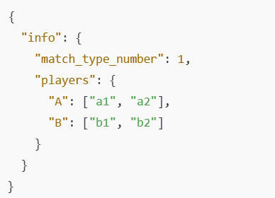

Convert it to:

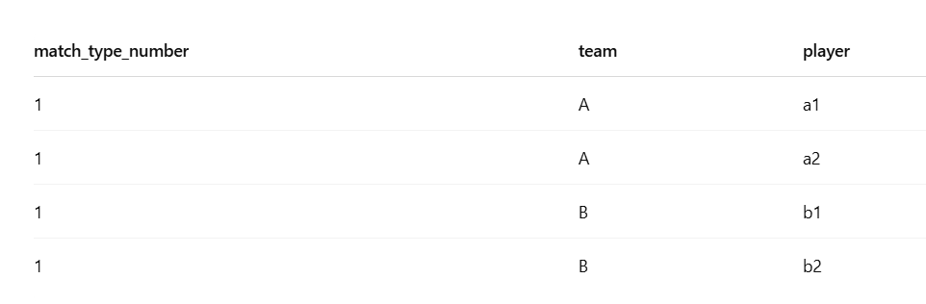

First showing raw data.  
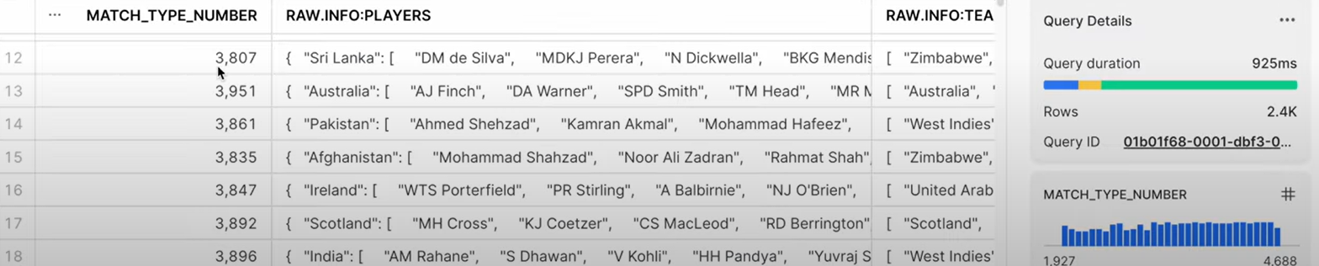

Lets consider any 1 record for any team and flatten the record.

Input.json

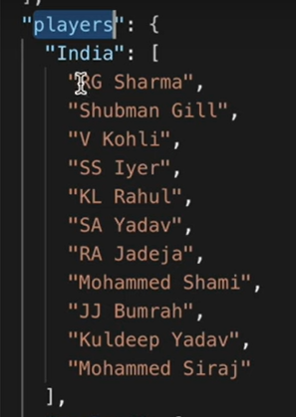

flattened output:

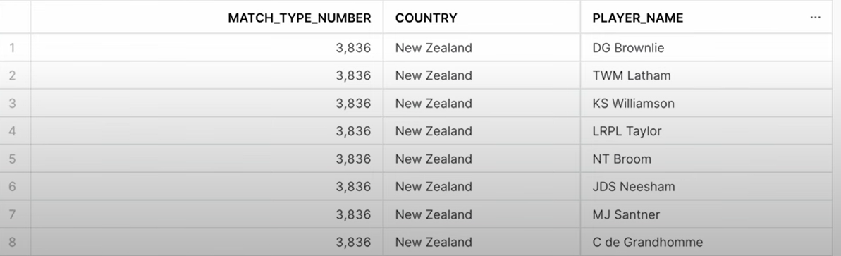

Flattened code:

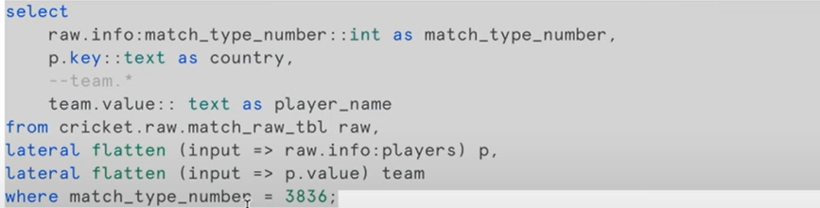

By default flatten is equi join, you need to explicitly mention, outer, left , right if you want to while flattening any json.

For eg:



Apply for all records:

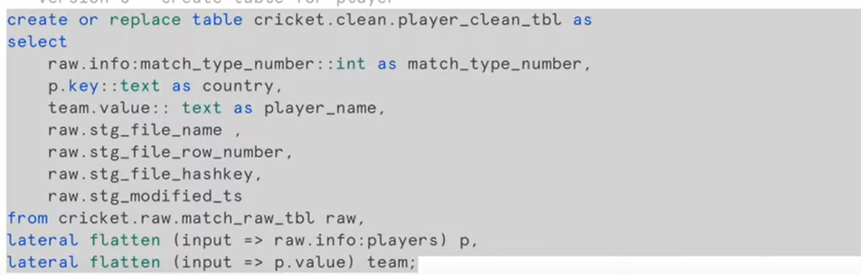

Code explanation by taking simple example.

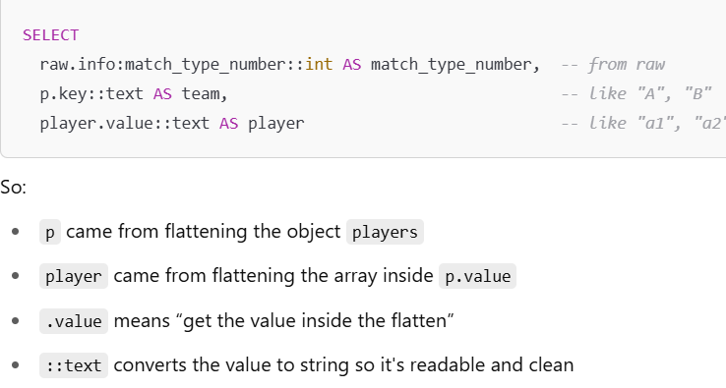

You can also create and view relationships.

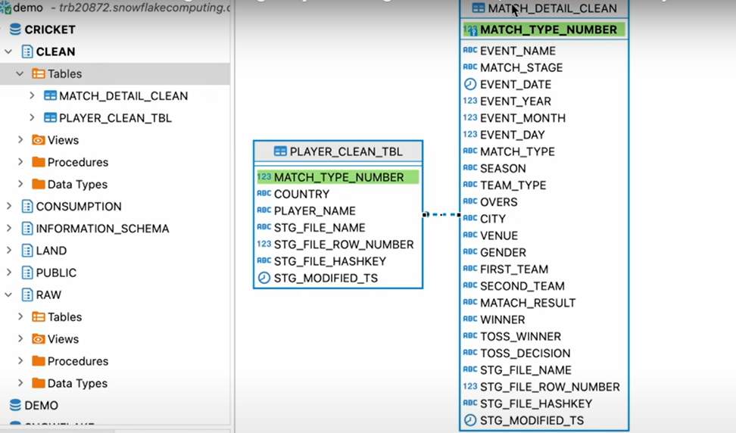

Now, lets Flatten innings:

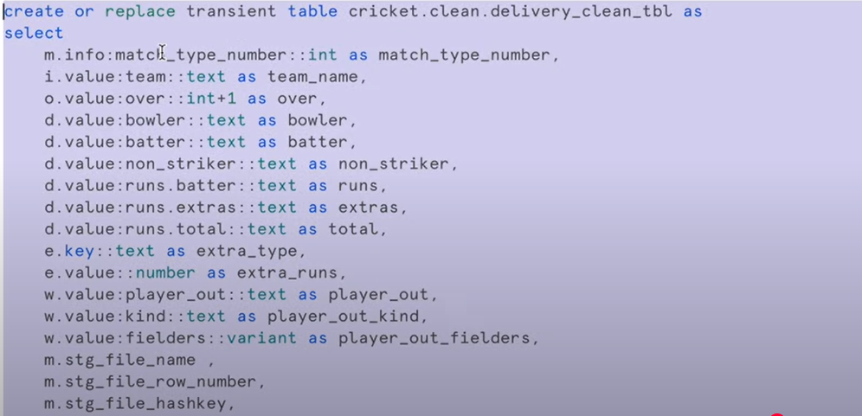

A **transient table** in Snowflake is a **normal table** that:

* **Stays saved** (even after you log out)
* Is **cheaper** to store
* Is used when you don’t care about backup or recovery

**Permanent table** = Saved + full protection

**Transient table** = Saved + less protection + cheaper

**Temporary table** = Not saved after logout

Final data review of the cleaned table

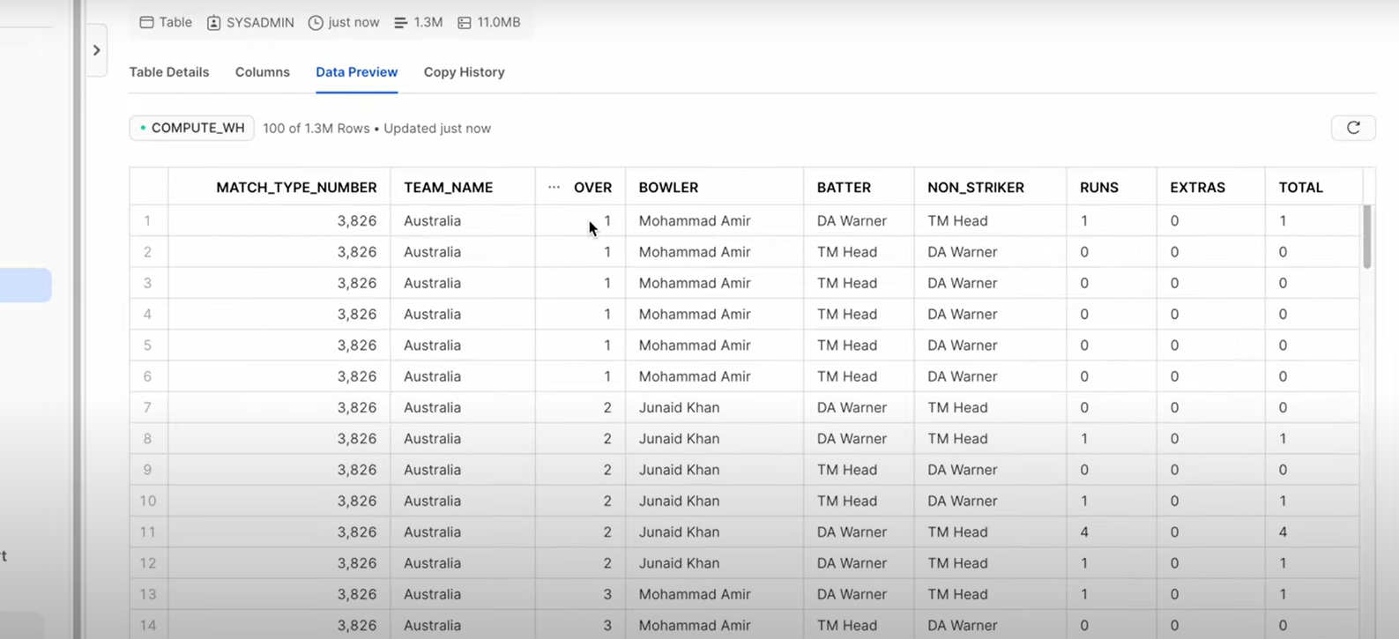

If any record is not there in the output table you need to describe the table and check what is the issue with that and decide either you want to filter it more or just drop that record or put anything default in that record.

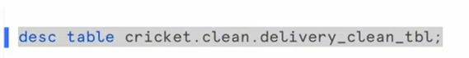

Alter the records if you want to make them clean. Who can also create relationships like foreign key relationships between two tables

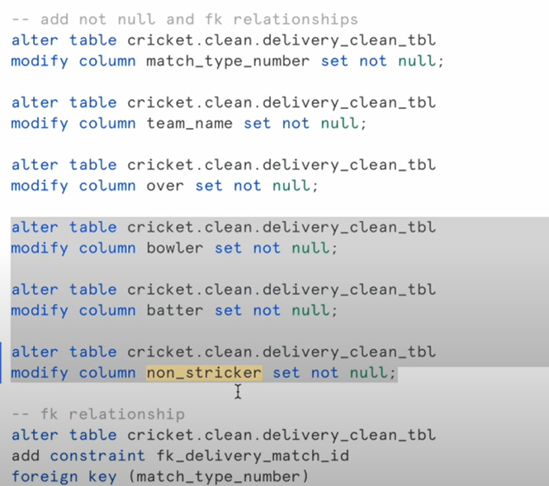

Relationship dig updated.

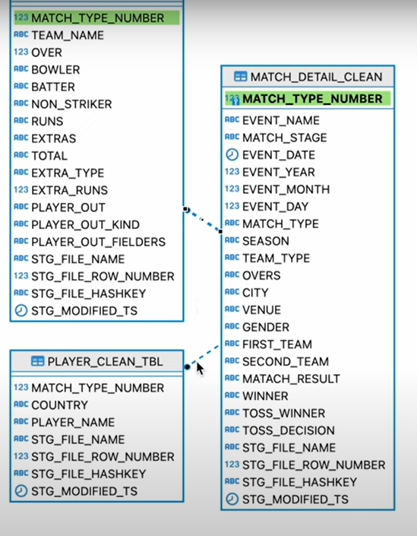

**DATA VALIDATION**

We populated data in three Tables let's check and validate that have been properly populated data in the three tables a lot

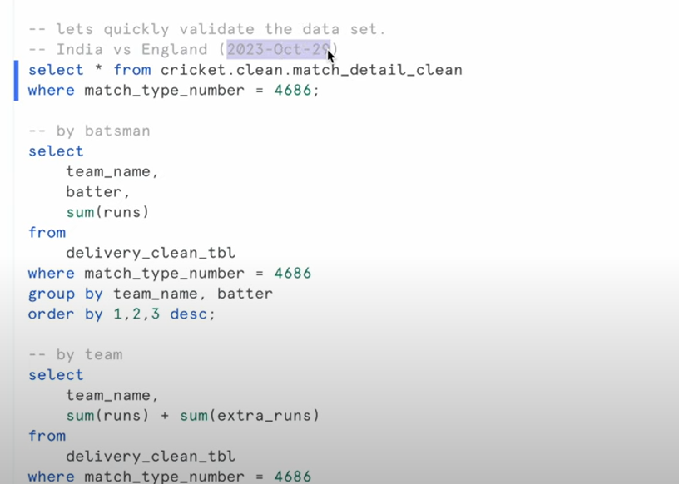

Go and check the json for the records and check the output populated for these queries.

Cleaned data.  
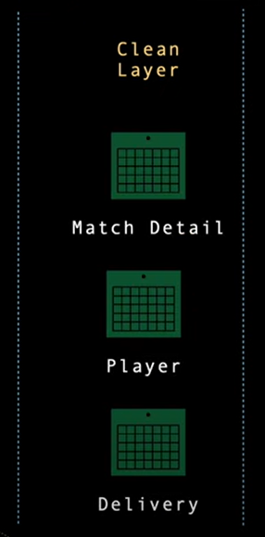

Consumption layer:

And now we had the raw data we cleaned it and now the data is in the clean layer now we have to convert the data into fact and dimension tables in the consumption layer.

So we need to combine all the three tables data and our final result should be that we should be able to answer the questions like how many matches player a played how many deliveries did the player a delivered in a particular match so all these questions need to be answered and for that we need to create fact and dimension tables of the cleaned layer data.

Basically we need to do that dimensional modelling:

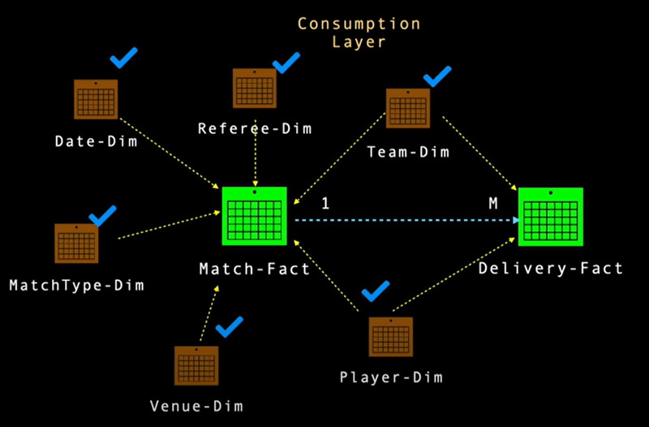

Need to create dimension table first and then the fact table.

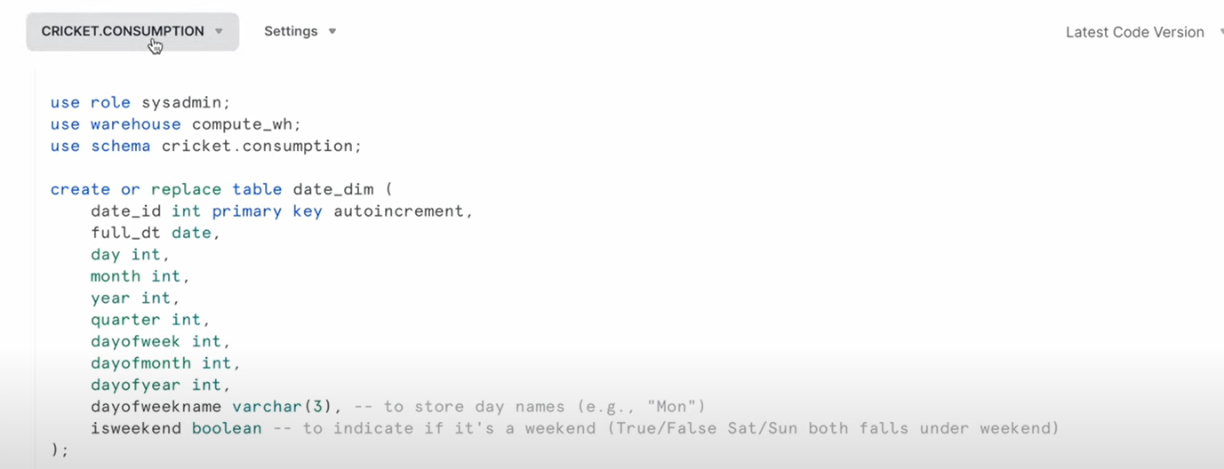

Dim date table Creation

create or replace table date_dim (

date_id int primary key autoincrement,

full_dt date,

day int,

month int,

year int,

quarter int,

dayofweek int,

dayofmonth int,

dayofyear int,

dayofweekname varchar(3), -- to store day names (e.g., "Mon")

isweekend boolean -- to indicate if it's a weekend (True/False Sat/Sun both falls under weekend)

);

## **Referee Dimension**

create or replace table referee_dim (

referee_id int primary key autoincrement,

referee_name text not null,

referee_type text not null

);

## **Team & Player Dimension**

create or replace table team_dim (

team_id int primary key autoincrement,

team_name text not null

);

-- player..

create or replace table player_dim (

player_id int primary key autoincrement,

team_id int not null,

player_name text not null

);

alter table cricket.consumption.player_dim

add constraint fk_team_player_id

foreign key (team_id)

references cricket.consumption.team_dim (team_id);

## **Venue Dimension**

create or replace table venue_dim (

venue_id int primary key autoincrement,

venue_name text not null,

city text not null,

state text,

country text,

continent text,

end_Names text,

capacity number,

pitch text,

flood_light boolean,

established_dt date,

playing_area text,

other_sports text,

curator text,

lattitude number(10,6),

longitude number(10,6)

);

## **Match Dimension**

create or replace table match_type_dim (

match_type_id int primary key autoincrement,

match_type text not null

);

## **Match Fact Table DDL Scripts**

CREATE or replace TABLE match_fact (

match_id INT PRIMARY KEY,

date_id INT NOT NULL,

referee_id INT NOT NULL,

team_a_id INT NOT NULL,

team_b_id INT NOT NULL,

match_type_id INT NOT NULL,

venue_id INT NOT NULL,

total_overs number(3),

balls_per_over number(1),

overs_played_by_team_a number(2),

bowls_played_by_team_a number(3),

extra_bowls_played_by_team_a number(3),

extra_runs_scored_by_team_a number(3),

fours_by_team_a number(3),

sixes_by_team_a number(3),

total_score_by_team_a number(3),

wicket_lost_by_team_a number(2),

overs_played_by_team_b number(2),

bowls_played_by_team_b number(3),

extra_bowls_played_by_team_b number(3),

extra_runs_scored_by_team_b number(3),

fours_by_team_b number(3),

sixes_by_team_b number(3),

total_score_by_team_b number(3),

wicket_lost_by_team_b number(2),

toss_winner_team_id int not null,

toss_decision text not null,

match_result text not null,

winner_team_id int not null,

CONSTRAINT fk_date FOREIGN KEY (date_id) REFERENCES date_dim (date_id),

CONSTRAINT fk_referee FOREIGN KEY (referee_id) REFERENCES referee_dim (referee_id),

CONSTRAINT fk_team1 FOREIGN KEY (team_a_id) REFERENCES team_dim (team_id),

CONSTRAINT fk_team2 FOREIGN KEY (team_b_id) REFERENCES team_dim (team_id),

CONSTRAINT fk_match_type FOREIGN KEY (match_type_id) REFERENCES match_type_dim (match_type_id),

CONSTRAINT fk_venue FOREIGN KEY (venue_id) REFERENCES venue_dim (venue_id),

CONSTRAINT fk_toss_winner_team FOREIGN KEY (toss_winner_team_id) REFERENCES team_dim (team_id),

CONSTRAINT fk_winner_team FOREIGN KEY (winner_team_id) REFERENCES team_dim (team_id)

);

For viewing relationships and tables(ER diagram). Connect it to your snowflake project

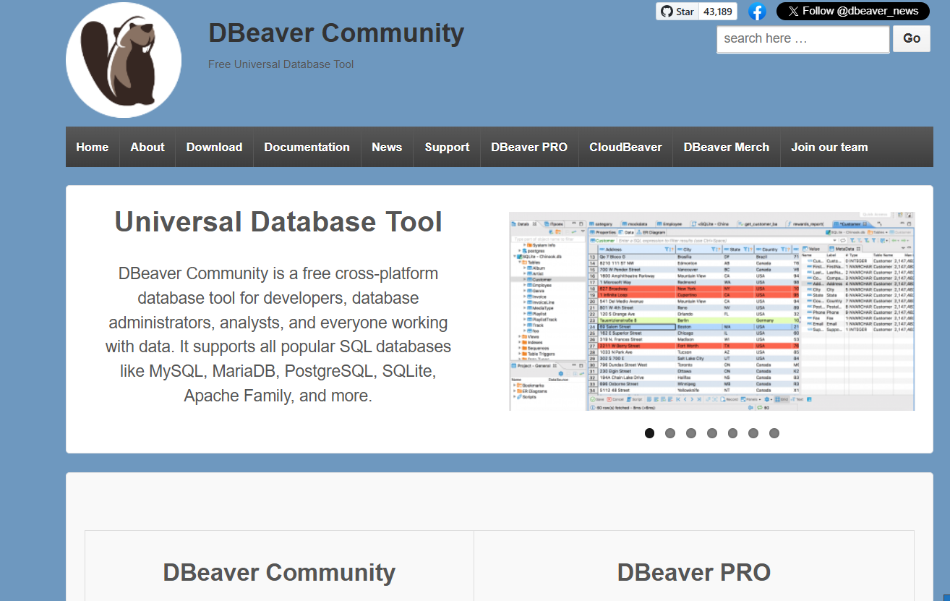

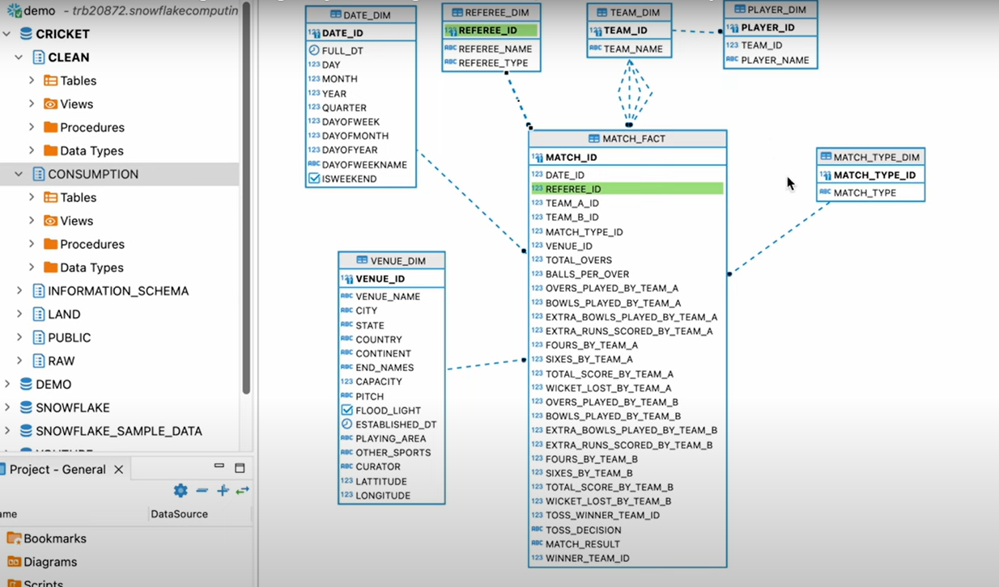

Now lets insert the data in all the created dimensions and the fact tables.

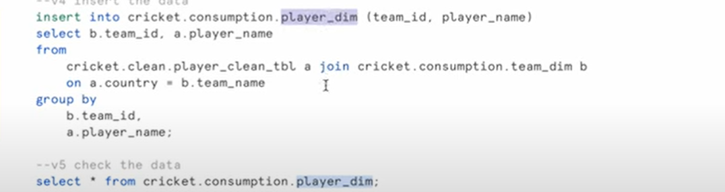

Follow the same for all tables.

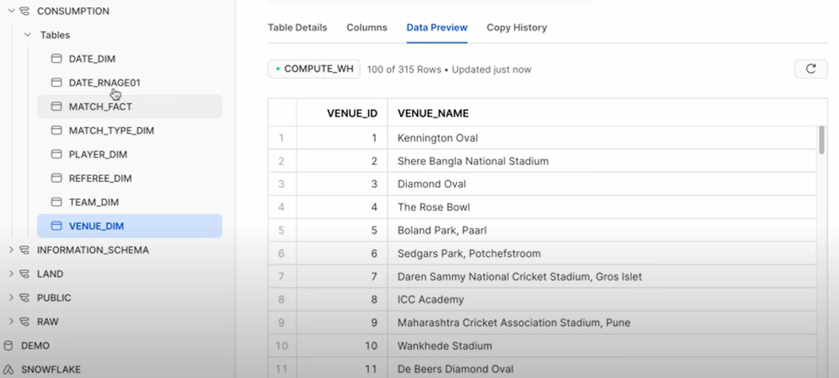

insert into cricket.consumption.match_fact

select

m.match_type_number as match_id,

dd.date_id as date_id,

0 as referee_id,

ftd.team_id as first_team_id,

std.team_id as second_team_id,

mtd.match_type_id as match_type_id,

vd.venue_id as venue_id,

50 as total_overs,

6 as balls_per_overs,

max(case when d.team_name = m.first_team then d.over else 0 end ) as OVERS_PLAYED_BY_TEAM_A,

sum(case when d.team_name = m.first_team then 1 else 0 end ) as balls_PLAYED_BY_TEAM_A,

sum(case when d.team_name = m.first_team then d.extras else 0 end ) as extra_balls_PLAYED_BY_TEAM_A,

sum(case when d.team_name = m.first_team then d.extra_runs else 0 end ) as extra_runs_scored_BY_TEAM_A,

0 fours_by_team_a,

0 sixes_by_team_a,

(sum(case when d.team_name = m.first_team then d.runs else 0 end ) + sum(case when d.team_name = m.first_team then d.extra_runs else 0 end ) ) as total_runs_scored_BY_TEAM_A,

sum(case when d.team_name = m.first_team and player_out is not null then 1 else 0 end ) as wicket_lost_by_team_a,

max(case when d.team_name = m.second_team then d.over else 0 end ) as OVERS_PLAYED_BY_TEAM_B,

sum(case when d.team_name = m.second_team then 1 else 0 end ) as balls_PLAYED_BY_TEAM_B,

sum(case when d.team_name = m.second_team then d.extras else 0 end ) as extra_balls_PLAYED_BY_TEAM_B,

sum(case when d.team_name = m.second_team then d.extra_runs else 0 end ) as extra_runs_scored_BY_TEAM_B,

0 fours_by_team_b,

0 sixes_by_team_b,

(sum(case when d.team_name = m.second_team then d.runs else 0 end ) + sum(case when d.team_name = m.second_team then d.extra_runs else 0 end ) ) as total_runs_scored_BY_TEAM_B,

sum(case when d.team_name = m.second_team and player_out is not null then 1 else 0 end ) as wicket_lost_by_team_b,

tw.team_id as toss_winner_team_id,

m.toss_decision as toss_decision,

m.matach_result as matach_result,

mw.team_id as winner_team_id

from

cricket.clean.match_detail_clean m

join date_dim dd on m.event_date = dd.full_dt

join team_dim ftd on m.first_team = ftd.team_name

join team_dim std on m.second_team = std.team_name

join match_type_dim mtd on m.match_type = mtd.match_type

join venue_dim vd on m.venue = vd.venue_name and m.city = vd.city

join cricket.clean.delivery_clean_tbl d on d.match_type_number = m.match_type_number

join team_dim tw on m.toss_winner = tw.team_name

join team_dim mw on m.winner= mw.team_name

--where m.match_type_number = 4686

group by

m.match_type_number,

date_id,

referee_id,

first_team_id,

second_team_id,

match_type_id,

venue_id,

total_overs,

toss_winner_team_id,

toss_decision,

matach_result,

winner_team_id

;

## **Delivery Fact Table Scripts**

CREATE or replace TABLE delivery_fact (

match_id INT ,

team_id INT,

bowler_id INT,

batter_id INT,

non_striker_id INT,

over INT,

runs INT,

extra_runs INT,

extra_type VARCHAR(255),

player_out VARCHAR(255),

player_out_kind VARCHAR(255),

CONSTRAINT fk_del_match_id FOREIGN KEY (match_id) REFERENCES match_fact (match_id),

CONSTRAINT fk_del_team FOREIGN KEY (team_id) REFERENCES team_dim (team_id),

CONSTRAINT fk_bowler FOREIGN KEY (bowler_id) REFERENCES player_dim (player_id),

CONSTRAINT fk_batter FOREIGN KEY (batter_id) REFERENCES player_dim (player_id),

CONSTRAINT fk_stricker FOREIGN KEY (non_striker_id) REFERENCES player_dim (player_id)

);

-- insert record

insert into delivery_fact

select

d.match_type_number as match_id,

td.team_id,

bpd.player_id as bower_id,

spd.player_id batter_id,

nspd.player_id as non_stricker_id,

d.over,

d.runs,

case when d.extra_runs is null then 0 else d.extra_runs end as extra_runs,

case when d.extra_type is null then 'None' else d.extra_type end as extra_type,

case when d.player_out is null then 'None' else d.player_out end as player_out,

case when d.player_out_kind is null then 'None' else d.player_out_kind end as player_out_kind

from

cricket.clean.delivery_clean_tbl d

join team_dim td on d.team_name = td.team_name

join player_dim bpd on d.bowler = bpd.player_name

join player_dim spd on d.batter = spd.player_name

join player_dim nspd on d.non_striker = nspd.player_name;

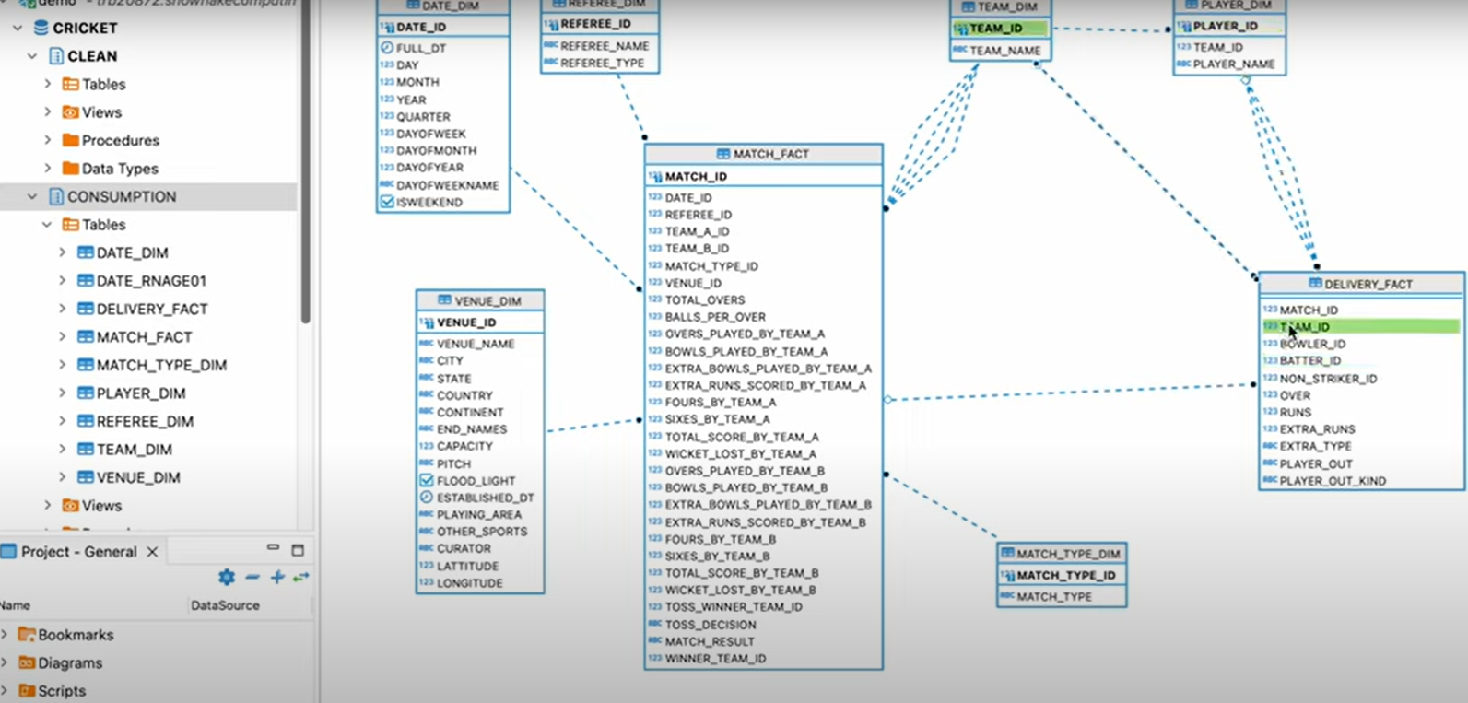

Visualizations:

Now the data which was in the clean layer is totally present in the consumption layer with proper relationships with the dimensions and the fact tables.

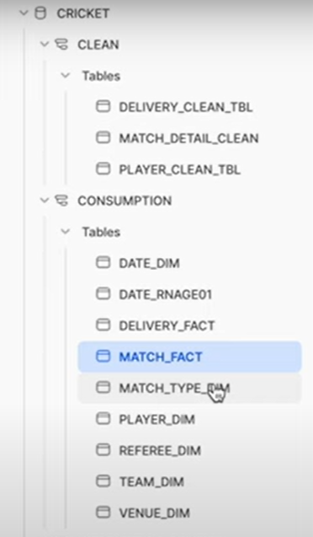

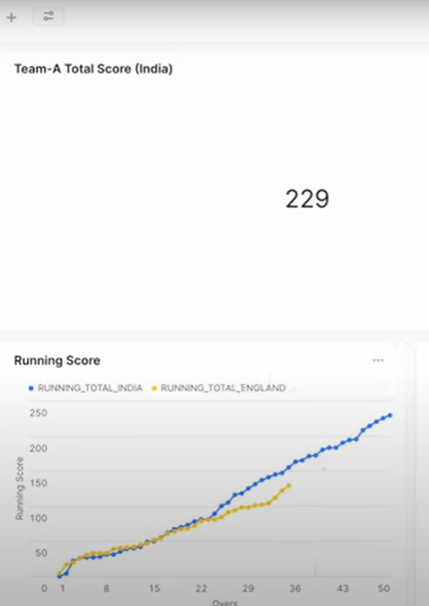

Automating all the flow by using task objects:

You need to go in the databases and in the graph section create the graphs

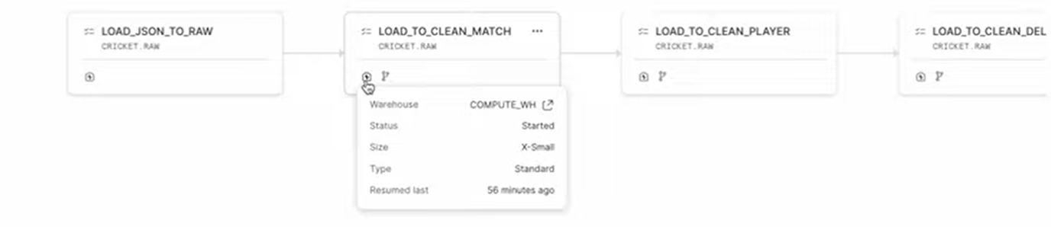

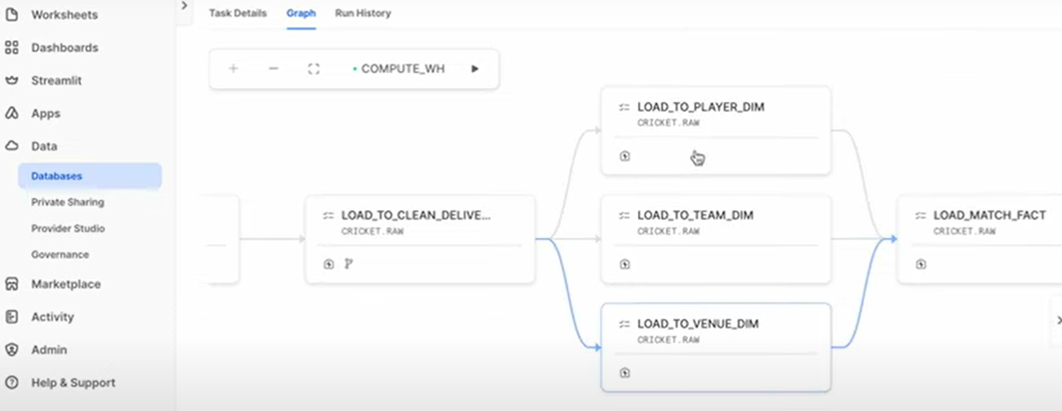

In the about screenshotyou can see that there are three parallel tasks running together

This directed acyclic graph has been created with sql script here is the sql script which populated this Directed Acyclic graph

### Step 1: Create streams on the raw table

sql

CopyEdit

create or replace stream cricket.raw.for_match_stream

on table cricket.raw.match_raw_tbl

append_only = true;

create or replace stream cricket.raw.for_player_stream

on table cricket.raw.match_raw_tbl

append_only = true;

create or replace stream cricket.raw.for_delivery_stream

on table cricket.raw.match_raw_tbl

append_only = true;

### **Step 2: Create a task that runs every 10 minutes**

sql

CopyEdit

create or replace task cricket.raw.load_json_to_raw

warehouse = 'COMPUTE_WH'

schedule = '10 minute'

as

copy into cricket.raw.match_raw_tbl from

(

select

t.$1:meta::object as meta,

t.$1:info::variant as info,

t.$1:innings::array as innings,

metadata$filename,

metadata$file_row_number,

metadata$file_content_key,

metadata$file_last_modified

from @cricket.land.my_stg/cricket/json

(file_format => 'cricket.land.my_json_format') t

);

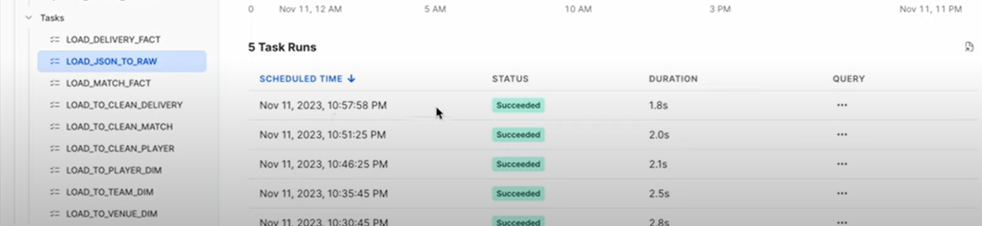

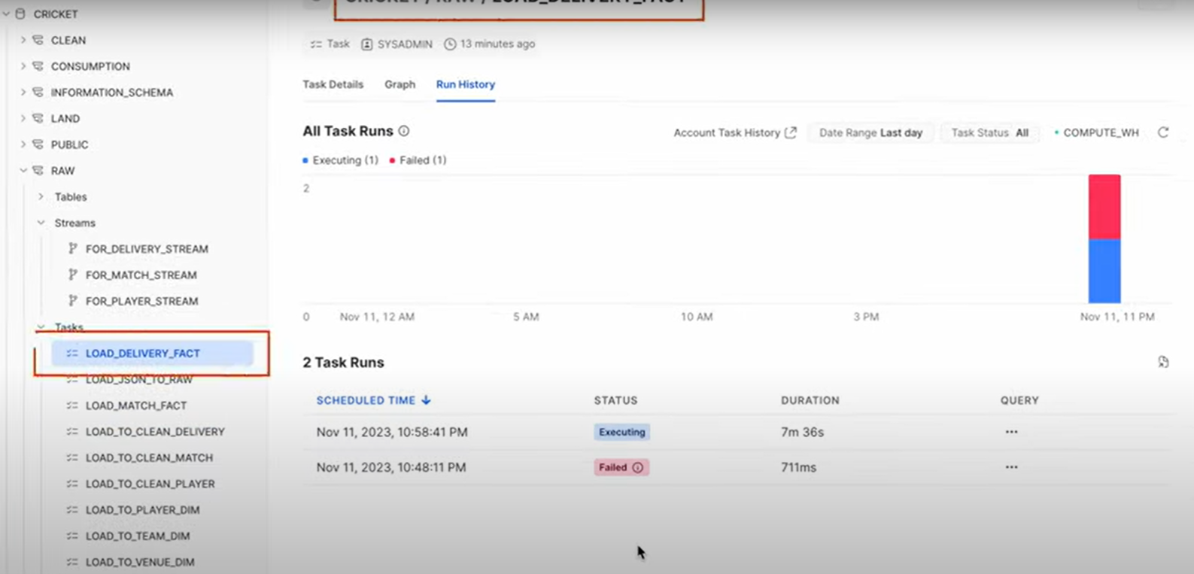

Challenges faced with the solutions:

* **1. Figuring out how to load JSON data from stage**
  + *Challenge:* I wasn’t sure how to load JSON files from the stage into a Snowflake table.
  + *Solution:* I used the COPY INTO command and followed examples to select specific parts of the JSON using $1:fieldname.
* **2. Choosing the right file format**
  + *Challenge:* I didn't know how to define a file format for the staged JSON.
  + *Solution:* I created a file_format with type = 'JSON' and used that in the COPY INTO command to make the structure readable.
* **3. Unsure about data types while loading**
  + *Challenge:* I was confused about using OBJECT, VARIANT, or ARRAY when selecting fields from JSON.
  + *Solution:* I read basic Snowflake docs and used ::variant, ::object, and ::array depending on the JSON structure.